**Herman Mann**

**CMSC 203**

**Assignment 5**

**Sales Report Implementation**

**GITHUB SCREENSHOTS OF ASSIGNMENT 5**

Screenshot of the result of loading “District 5”

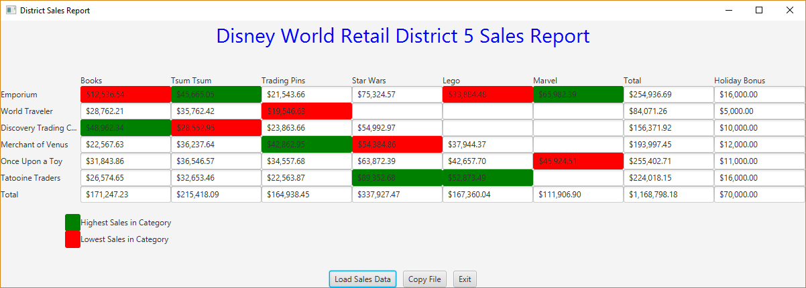

File containing sales data (including negative numbers):

Result after selecting Load Sales Data:

JUNIT student Test cases implemented

JUNIT student test Holiday Bonus implemented

JUNIT student test TwoDimRaggedArrayUtility implemented

JUNIT student test TwoDimRaggedArrayUtility implemented

Reflection Paragraphs

Throughout the completion of Assignment 5, I learned about how we can use a variety of different methods to make it useful for a successful project implementation like this one. I learned that the combination of the three different classes of TwoDimRaggedUtility and HolidayBonus all came as one to develop a successful working algorithm of calculating the Holiday bonuses of each store depending on the lowest and highest sales of a single category. This was done greatly using concept of static methods of the TwoDimRaggedUtility class. I learned that the use of setters and getters are so useful to a java program to make it more convenient to a user to understand the basis of what is happening of how the getColumn, get RowTotal, getTotal, getHighestColumnIndex, etc are getting used producing the totalholiday bonus of a sales category itself. I learned that working with this project involved the great use of conditional statements, repetition structures of loops like the for loop, use of various different types of methods, and the Javadoc commenting for the project to make it look more professional and ideal for any programmer to utilize the making of this project into a very successful one.

I struggled with the HolidayBonus.java method, and how to really do it all together. When it came to returning the result of calculating of the total bonus, I was not sure how to do it. I finally solved my problem by testing out very different things like calling the getHighestInColumnIndex and getLowestInColumnIndex and happened to work and passed the JUNIT tests successfully, both the student and the general TwoDimRaggedArray and HolidayBonus tests. I did not encounter any other issues, but the other issue was my calculateTotalHolidayBonus test of HolidayBonus test, it kept failing and failing and I got extremely frustrated. I found out the error came from my incorrectly implemented getHighestInColumnIndex method. I fixed the issue of the method, and the error was that it didn’t return any false or true value of when it was considered the certain index or not until I created two new int variables of max and the new index. I solved my issue successfully. I would start my projects way on time and focus on stepping out on smaller parts of the project to develop it more properly and accordingly to make it more informative and understandable to other programmers itself.

This project made me realize there are a lot of great and wonderful features of the Java program itself, the utilization of the different methods, setters and getters, the use of a GUI (graphical user interface), the Javadoc and the total by part of each method to contain so much detail oriented code of the Java language in one system of things. The combining of the two classes into creating one big and great algorithm shows the creative and unique ways of Object-oriented programming and how it is such a big thing in this world and for the future, and making the future way more advanced due to the object-oriented techniques and skills the Java program stresses its importance on. Also, the implementation of do not repeat code comes into play with the Java programming and it showed me the example throughout the successful completion of this project.